**After the Golden State Warriors acquired former MVP Kevin Durant in 2016, some NBA fans speculated that the Warriors would not lose consecutive games at any point of the season**

If you wanted to determine the probability that this prediction would be true (i.e., that the Warriors would never lose consecutive games at any point during an 82-game season), what is one approach (or a few approaches) you may use to solve the problem? What answer do you get? Exact answers are of course welcome, but approaches that lead to approximations (and those approximations) are fine, too (please specify the precision of your estimate). Assume the Warriors have an 80% chance of winning each individual game.

**By Kevin Liu and Justin Tran**

This problem can be solved by applying the Monte Carlo method. All we needed were the probabilities of winning games (given as 0.80). The data could account for randomness by including a standard deviation from that probability but it is not needed for a rough calculation of the wins that the Golden State Warriors will not lose consecutive games. We also assume that the probability does not change at any time during the season and does not change based on the winning probability of their opponents

Here is one possible solution: We simulate 82 separate games for the Warriors **n** number of times where **n** represents number of seasons. Each game can be randomized by randomly generating a number from [0.0, 1.0) (Bernoulli Distribution). If the number generated is less than 0.80 than that counts as a **Win** for the Warriors. If the number generated is 0.80 or greater, the Warriors **Lose**. If we perform simulations of these games enough times to complete **n** number of 82-game seasons we will have a plausible probability of the chances this prediction is true.

We can then use a program to count the number of times a Loss **never** shows up back-to-back at any point within a single season for the Warriors and count that. We count each season where this is no generated back-to-back loss and divide that by **n** number of seasons to find the probability that the Warriors don’t lose consecutive games at any point in the season.

After completing a short Python script simulating this situation with n = 1,000,000 seasons, the probability of the Warriors not losing consecutive games in a season came out to be **approximately 0.058**. Attached is a screenshot of one such simulation.

The standard error of the mean was calculated with **sigma/sqrt(n)** where sigma is the standard deviation and n is the number of samples. To do this we get the standard deviation from running a simulation of 1,000,000 season another **x** number of times. We’ll use **x = 10** as our number this time around to calculate it.



As we can see, **our estimate is off by a standard average of approximately 4.696E-5** meaning out estimate is very precise.

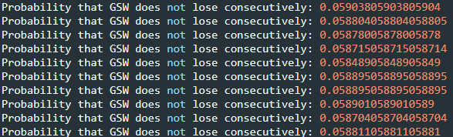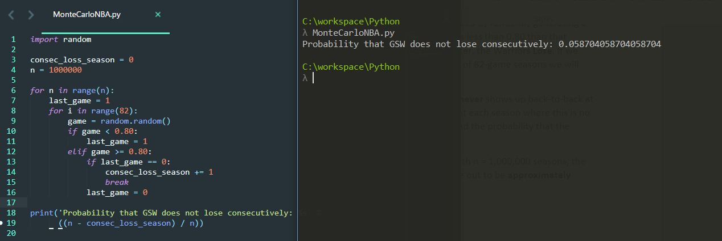Probability of losing consecutively in games when running 1,000,000 seasons.

Running the 1,000,000 season sample 10 times to calculate standard deviation and subsequently the Standard Error of the Mean found above.